Week3 Day2 Assignment
Read my entire workspace and understand how UI implemented in the frontend folder
I want to add "Connect Jira" button to establish the connection. Once the Jira is connected upon clicking the button, worklist/feature should be populated in the UI screen. Upon clicking the link, it should auto populate the summary, description details in the form.
[STRICTLY] DO THE IMPLEMENTATION ONLY ON UI
Base url - https://srividhyasrinivasan79.atlassian.net
Email id - srividhyasrinivasan79@gmail.com
Jira API key – (confidential)- given in the prompt
Project Key - GA2
Endpoint - https://srividhyasrinivasan79.atlassian.net/rest/api/3/search/jql?jql=project = GA2 ORDER BY created DES

Result –CONNECT JIRA button added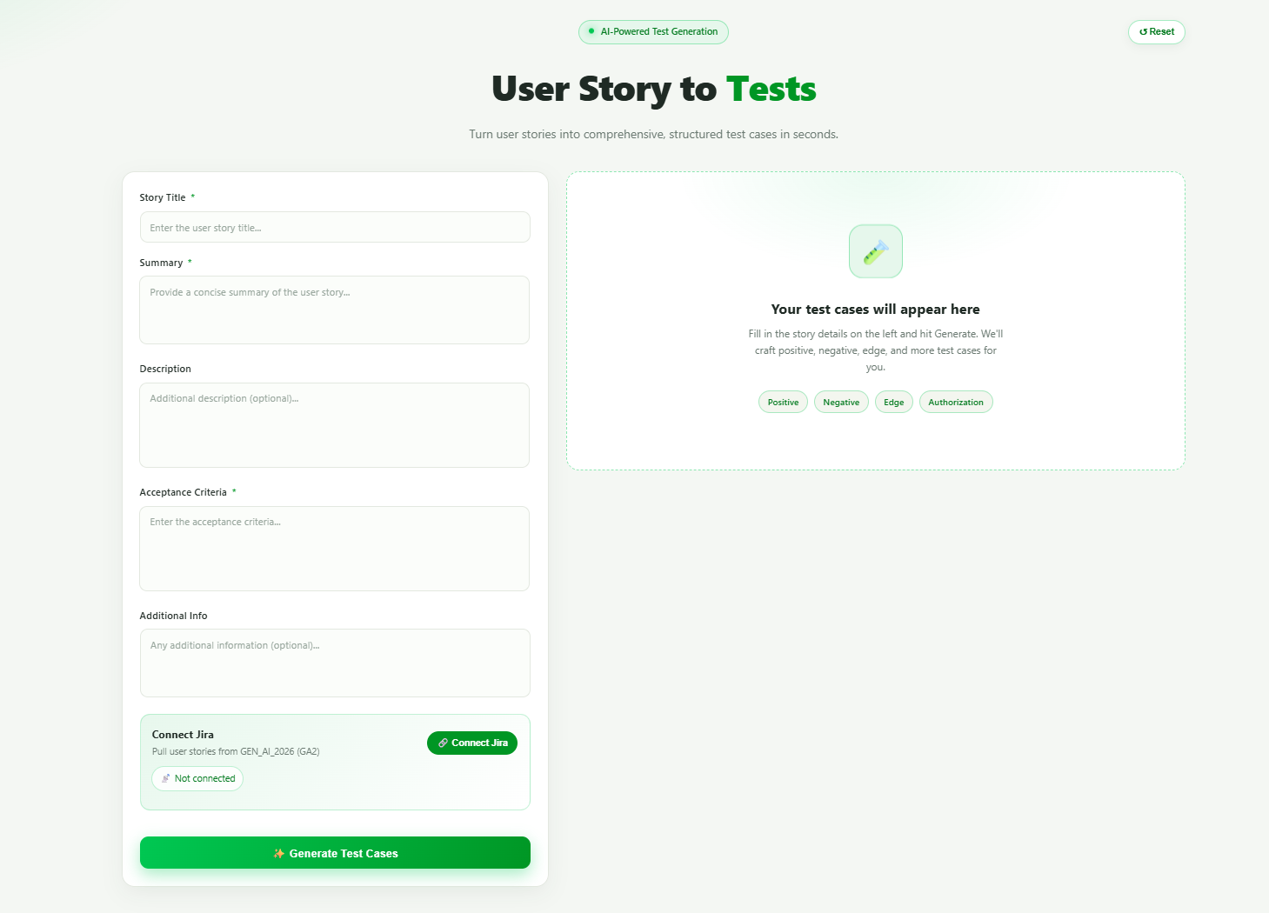
After Connecting, it published the existing Work list from JIRA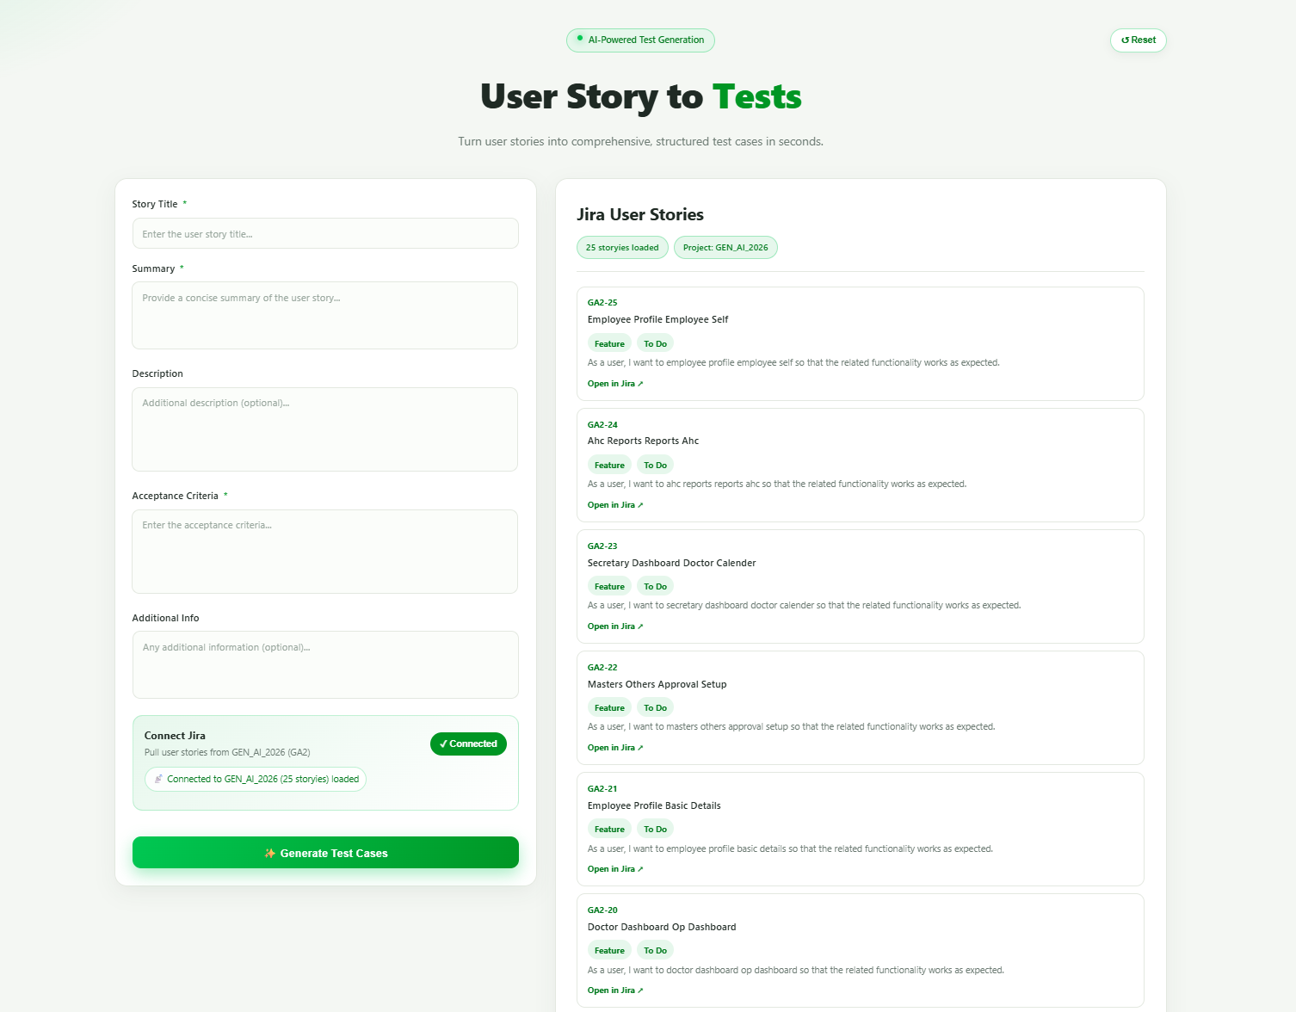
Implementation done in such a away after clicking the ID, would autopopulate the summary, description to the form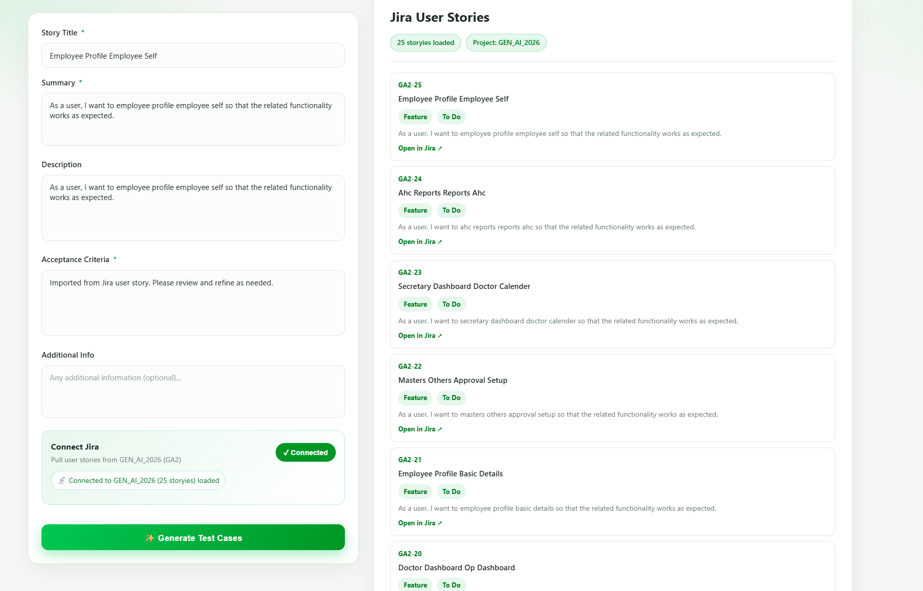

After clicking Reset Button

